Project: |  |  | Manufacturer.:
Region: |  |  | Model No.:
Service: |  |  | Number of Units:
Equip. Tag Number(s)*: |  |  | Rev/Date/By: / /
GENERAL REQUIREMENTS
Equipment Capacity: kg (___tons) | Factory Testing: |  | Power Supply:
Method of Control: | Required Not Required |  | Voltage
Location of Control: | Field Testing: Not required |  | Phase
Equipment Location: | Required, functional and |  | Frequency
Indoors Outdoors | performance
HOIST |  | TROLLEY
Type: |  | Type:
Electric, Wire Rope Hand Operated, Chain |  | Top Running Underhung
Service Class (ANSI): |  | Service Class (ANSI):
H1 (standby) H2 (light) H3 (standard) |  | A1 (standby) A2 (infrequent) B (light)
H4 (heavy) H5 (severe) |  | C (moderate) D (heavy)
Speed cm per minute (fpm): to |  | Speed cm per minute (fpm): to
Constant Speed Two Speed Variable Speed |  | Constant Speed Variable Speed Hand Operated
Motor kW (hp): |  | Motor kW (hp):
Hook: See Hoist/Monorail Dimension Sheet |  | Electric Conductors:
Hook Manufacturer: |  | Bus Bar Festoon
 |  | Cable Reel
SPECIAL REQUIREMENTS
Accessories: | Remote Controls:** |  | Special Electrical Requirements:
Central Lubrication System | Infrared, line-of-sight
OHSA operating and safety | Frequency modulated (FM)
devices | Manufacturer:
 | Extended Grease Fittings
See Hoist/Monorail Dimension Sheet for clearances, lift distances, and details.
*Equipment Tag Number shall conform to the Region’s Tagging Standard. Refer to Section 21 – Development and Maintenance of Asset Inventory and Tagging.
[DESIGN NOTE: Consultant to modify to chosen type of crane remote control above in the “Special Requirements” section (radio or pendant hard-wired)]

Project:
Region:
Equipment Tag Number(s):
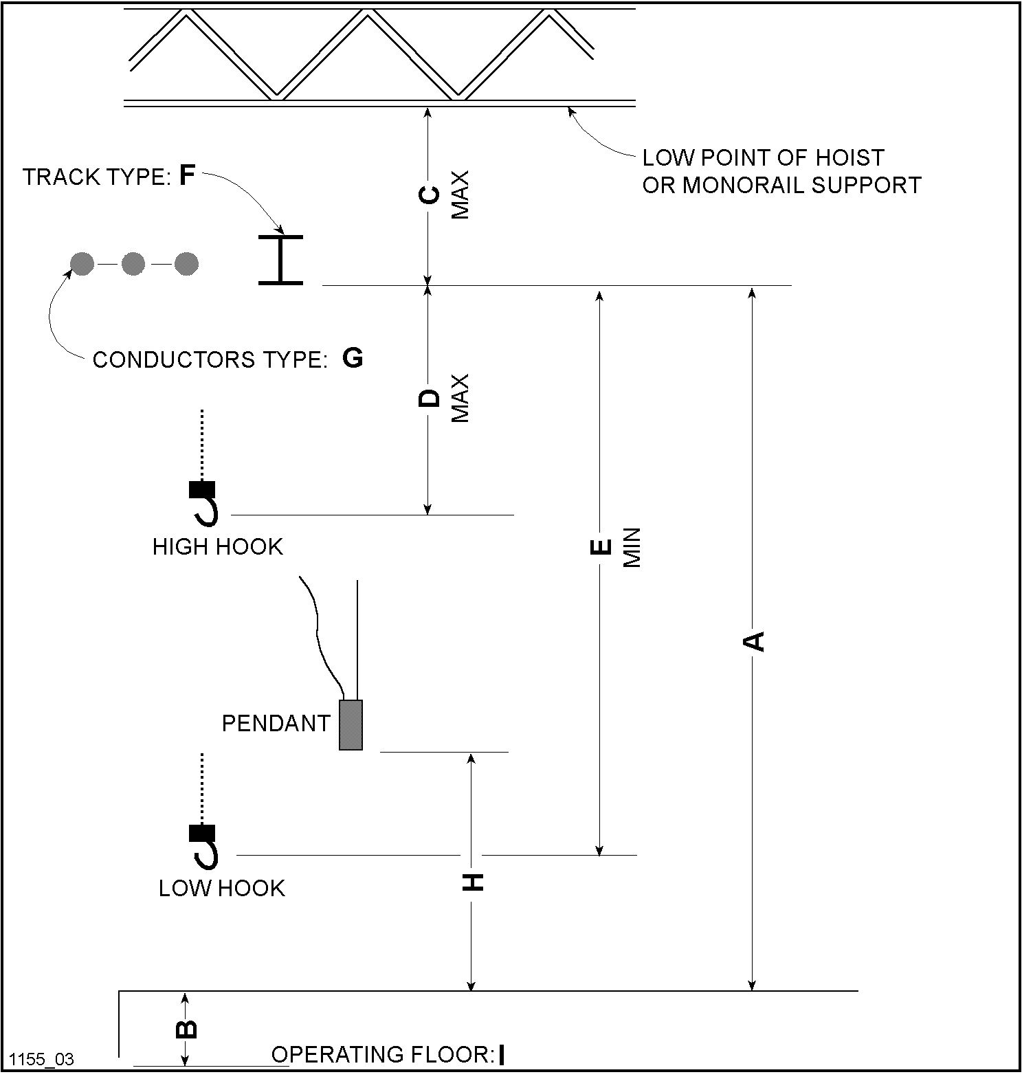
A: | D: | G:
B: | E: | H:
C: | F: | I:

